Task1

Name: Ahmed Mohsen Ahmed

ID: 202200061

**Brief description:**   
In this task we implement a simple shell that loops until command is given or we exit from the shell it handles both external and internal commands and execute them, few of these commands are changing directories , listing directories, list all environmental variables, setting environmental variable, echoing a message , help menu for user, pause function and finally a quit function to exit the shell, also shell can take commands directly from a file by opening file and reading content of file it runs all commands then exits the shell at the end of the file it also handles input and output commands like taking input from file or inputting something into a file and output things from file and outputting result into a file this works for both external and internal commands and it can also run background execution while in shell which cannot be seen by the user.

**Screenshots of output**:

All internal commands:

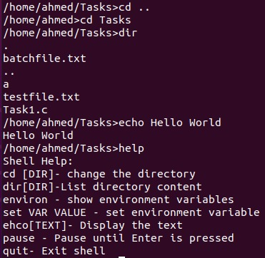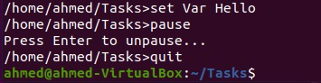

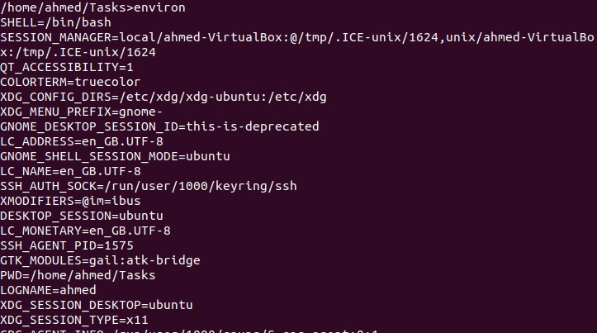

Running file in shell:

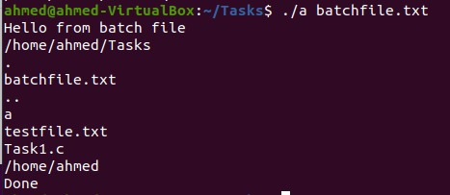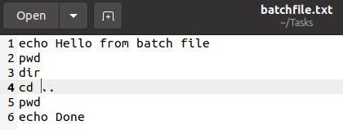

Writing/ inputting into a file:



C:\Users\user\AppData\Local\Microsoft\Windows\INetCache\Content.Word\WhatsApp Image 2025-01-30 at 18.07.57.jpeg

Appending into a file:



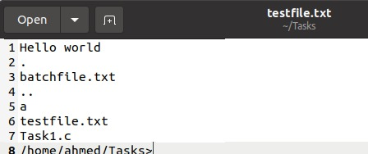

Take input from a file:



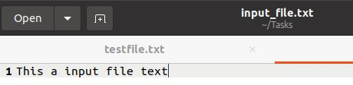

**GitHub link:**<https://github.com/Cookieking2490/Operating-system-tasks>